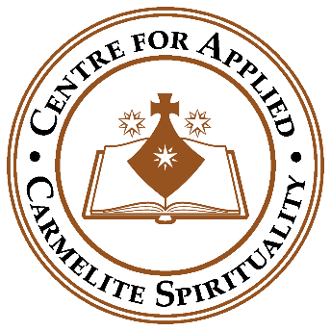
Supplement 8

What to do if a person from overseas raises a concern or allegation
whilst you are speaking to them, either in a group or individually
as a Friar or volunteer of CACS
And
Resources in reference to International Safeguarding

An International global hub

The Centre for applied Carmelite Spirituality is a global hub. People from each continent of the world join us in worship, learning, spiritual direction, and guided retreats in person and online. We follow the advice given from the RLSS (Religious Life Safeguarding Service, should such an allegation arise). The RLSS have a specialist advisor in reference to international safeguarding.

What to do if you receive an allegation from a person living abroad whilst working for CACS as a volunteer or Friar?

As a member of the Oxford Priory or as a volunteer working for CACS if you need advice or to report a safeguarding concern or allegation, you must follow the procedure in our Safeguarding policy which is to contact Fr. Liam Finnerty OCD, or Father Nicholas Macedon OCD, his deputy. No other steps must be taken until this contact is made.

Fr Liam Finnerty OCD
Email: safeguarding.cacs@carmelite.org.uk
Mobile number:+44 7510 175621

Fr NicholasMacedon, OCD
Email: frnicholas@carmelite.org.uk
Mobile number: +44 7767 184812

Recruitment from overseas for CACS volunteers or paid staff

It is not possible to undertake a DBS disclosure on individuals from overseas. It is though possible to undertake a ‘Certificate of Good Conduct’ check from many countries. Once an individual has been in the UK for six months a DBS disclosure should be undertaken.

A ‘Certificate of Good Conduct’ check is best obtained via the Embassy or Consulate of the country the individual is from.
The following will always be considered:

- It is not always possible to obtain a certificate from countries that do not have functioning criminal record regimes or refuse to provide these to anyone other than their own citizens.

- Not all behaviours of a sexual or violent nature that would be considered an offence in the UK would be in other countries.

- The age of consent and the age of criminal responsibility differs in many countries.

- Information supplied by an Embassy or Consulate may require translation.

- An understanding of criminal law in a country may assist risk assessment.

The DBS provide details of which countries provide Certificate of Good Conduct
https://www.gov.uk/government/publications/criminal-records-checks-for-overseas-applicants

Guidance on the application process for criminal records checks overseas
https://www.gov.uk/government/publications/criminal-records-checks-for-overseas-applicants/guidance-on-the-application-process-for-criminal-records-checks-overseas

What are the challenges in working in an international context for CACS?

- You must remember that the starting point for CACS is we meet the standards laid down by Catholic Safeguarding Standards Agency and we are advised how to enact these standards by Religious Life Safeguarding Service.
- The RLSS would advise us on any issue that arose internationally, therefore the safeguarding lead and his deputy will have a general knowledge, but it is the specialist at the RLSS who would lead on any concerns or allegations that arose internationally.
- Civil law differs from country to country and indeed for example in the USA from state to state.
- Domestic abuse and domestic violence is not a crime in every country of the world. Other issues we may see as abuse may not be seen as that in other countries.
- Likewise the age of consent varies from country to country.
- CACS does not set up hospital or schools internationally but if CASC did the workers would need extensive training in managing safeguarding which is provided by agencies such as www.thirtyoneeight.org
- Safeguarding Resource and Support Hub: This is an outstanding international resource for safeguarding. https://safeguardingsupporthub.org/

